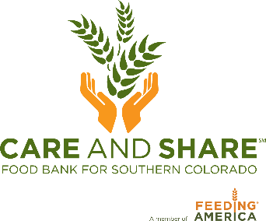

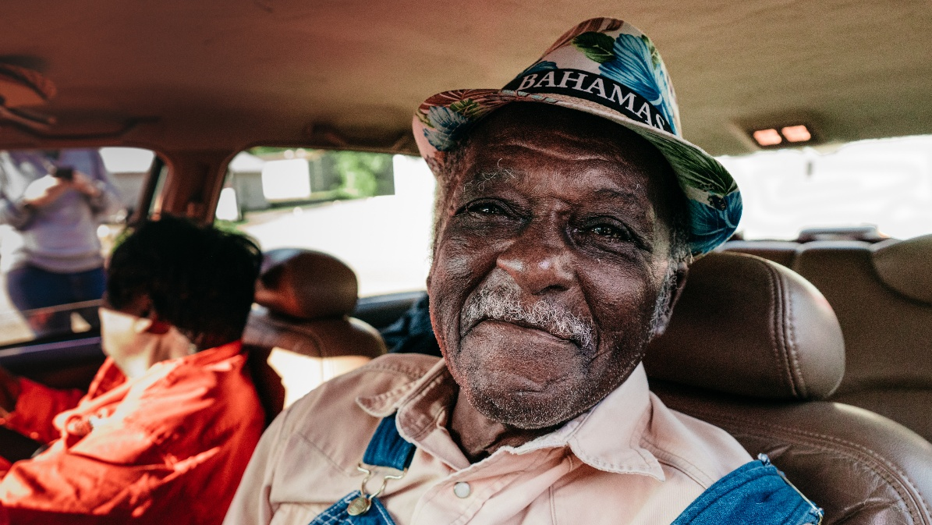

SNAP Outreach Program

What is the Supplemental Nutrition Assistance Program, (SNAP)?
SNAP is a federally funded food assistance benefit administered in Colorado by each county’s Colorado Department of Human Services (CDHS). SNAP is designed to be a bridge, while food banks help fill in gaps — especially in emergencies or when income falls short of housing expenses. It helps low-income individuals and families afford groceries by providing monthly benefits loaded onto an Electronic Benefit Transfer (EBT) card — like the Colorado Quest Card — which works much like a debit card at authorized food retailers.

Benefits for the Community Overview of the Program
The SNAP Outreach program brings a trained experienced SNAP staff member to communities experiencing gaps in food access. Our SNAP staff can assist with submitting new applications, recertification, change reports and answering questions at your site location. (Your local CDHS office will complete the required interview and determine eligibility and benefit amount if you are determined eligible.) Care and Share is seeking host sites that share our mission of addressing food insecurity and are equipped to support the program. Please complete this application to express your organization's interest in hosting the SNAP Outreach program.

Pre-Partnership Checklist– Step One
The SNAP Outreach Program allows Care and Share Food Bank to partner with community leaders, businesses, organizations, churches, etc. for the purpose of serving their immediate community, providing direct service to those in need of addition funds for food. The pre-partnership checklist outlines the minimum requirements necessary to become a host site.

- Able to market the days and times of the SNAP Outreach
- Supply a semi-private area with a table and chair
- Provide two points of contact day-of for smooth communication
- Access to secure Internet connection and copier
- Should be in an area or community experiencing gaps in food access
- Location is in a safe and accessible space for neighbors to access

If a proposed host site can meet these six requirements, they are encouraged to complete our online application. If a proposed host site cannot meet the requirements above, we encourage them to reach out to our SNAP Manager, Jo Stinchcomb at jo@careandshare.org to see if accommodations can be made.

Complete the SNAP Outreach Program Host Site Application – Step Two
The application is intended to help us understand and highlight your community’s specific needs, ensuring we can use our limited resources responsibly and effectively. In 2026-27, Care and Share will prioritize support for rural communities with limited access to food and urban areas where services are scarce or unavailable. Care and Share reviews application on a rolling basis. Interested host sites need to complete an application. Deadlines for the application are listed below. We review on a quarterly basis, and sites only need to apply once a year.

- Host in January-March; Deadline is December 1st
- Host in April-June; Deadline to apply is March 1st
- Host in July-September; Deadline to apply is June 1st
- Host in October-December; Deadline to apply is September 1st

The application is good for up to one year.

Areas of Focus
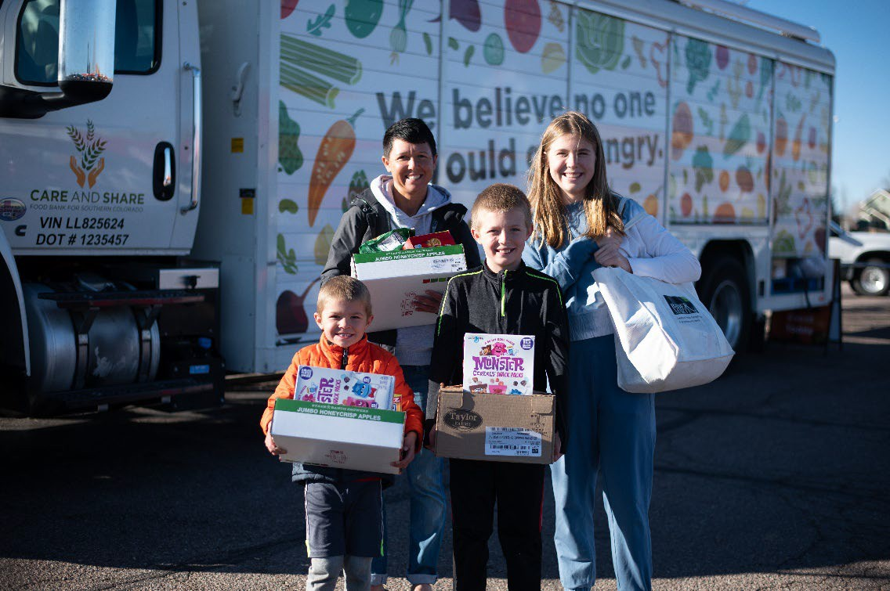
By customizing our SNAP Outreach Program we can address our areas of focus, it becomes an adaptable tool in addressing food insecurity and ensuring equitable access of nutritious food for those in need.

How the SNAP Outreach Program helps: The SNAP Application Assistance Program allows neighbors to have confidence in applying for SNAP with a trusted organization and trained SNAP staff member. If qualified, neighbors receive extra grocery dollars and have a choice of the foods they put on their tables.

High transportation barriers
Areas where residents face difficulties accessing transportation, limiting their ability to travel for food or essential services.

Why it matters: For residents without reliable transportation, even a short distance to the nearest CDHS office can be an insurmountable obstacle.

How the SNAP Applications Assistance Program helps: By bringing trained SNAP staff to centralized locations within these communities, we eliminate the need for residents to travel far, reducing the burden of transportation barriers.

Economic challenges (e.g. poverty, unhoused, unemployment, etc.)
Regions with high rates of poverty, unhoused, unemployment, or other economic hardships hinder access to basic needs. Utilizing SNAP benefits can help families put food on their tables.

Why it matters: Economic hardships often mean neighbors must choose between food and other essentials like housing, healthcare, or utilities.

How the SNAP Application Assistance Program helps: By putting extra grocery dollars in the pocket of neighbors that qualify. Easing the financial strain on families, ensuring they can meet their basic nutritional needs despite economic challenges.

Complicated paperwork or digital literacy challenges for residents
Neighbors can struggle with the complicated 8-page paper application or the computer website that allows them to apply. This can include senior residential communities.

Why it matters: Individuals with health conditions, disabilities, or mobility issues may struggle with a physical or digital application.

How the SNAP Outreach Program helps: The SNAP Application Assistance Program creates a convenient and inclusive solution by bringing SNAP experts that walk them through the application process and submit their application directly to the county. Hence making it easier for individuals that may need assistance applying, re-certifying, submitting change reports or just the opportunity to ask questions.

Limited Internet Access or Data and Privacy Concerns
Locations isolated by distance, terrain, or other physical barriers, making it challenging for residents to access Internet or they may have concerns about utilizing the Internet.

Why it matters: Rural or remote areas often face logistical challenges in accessing the Internet due to physical distances, rugged terrain, or a lack of infrastructure.

How the SNAP Outreach Program helps: The SNAP Outreach Program bridges the gap by reaching these underserved areas by supplying safe secure internet access ensuring residents in geographically isolated locations have access to work with a trusted SNAP trained staff member in person.

Complete the 2026 Host Site Agreement – Step Three
Each host site is required to review and complete our host site agreement. This will be provided to the host site when they receive their award email. The agreement must be signed and returned to Care and Share before hosting the first SNAP Outreach Program.

The host site agreement is good for one year.

Host your First SNAP Outreach Program – Step Four
Below is a checklist of things the Host Site should do before hosting:
- Fill out the SNAP Outreach Program application (online)
- Advertise the availability of the SNAP Outreach Program to the community
- Prepare a semi-private area with a table and 2-3 chairs
- Ensure secure internet and copier access is available

We encourage outreach activities in addition to the SNAP Outreach Program to engage
neighbor participation.

Frequently Asked Questions
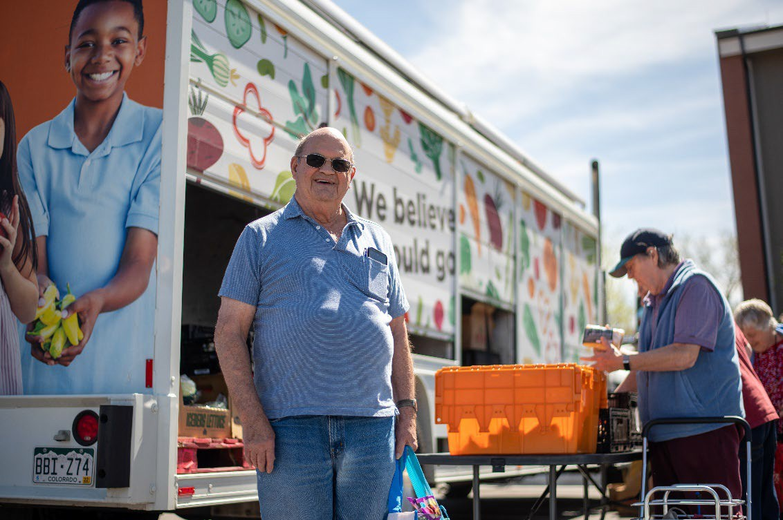
How does the SNAP Outreach Program work?
The SNAP Outreach Program is to create a safe convenient way for neighbors to access assistance to apply, re-certify, submit chance reports and ask questions about SNAP food benefits. We go to locations where our neighbors in need frequent. The goal of the SNAP Outreach Program is to reduce barriers that neighbors may experience when possibly eligible to receive SNAP food benefits but they don't know where to start. SNAP provides a bridge for low-income families in need of extra grocery dollars the ability to supplement their income and easily access the foods they may need.

How many neighbors can the SNAP Outreach Program serve while at my site?
The SNAP Outreach staff can easily assist up to 8 neighbors in a 2-hour period. In addition, neighbors are welcome to set up and appointment with SNAP staff to receive a phone call and receive assistance at a more convenient time if needed.

How do I host a successful SNAP Outreach Program?
The three key aspects to hosting a successful SNAP Outreach Program are, 1) advertising to our neighbors ahead of the scheduled day/time, 2) setting up a semi-private area with table and chairs, and 3) hosting the SNAP Outreach Program in a location with high visibility and in a high-need area.

Is the host site responsible for advertising the Mobile Market?
Care and Share Food Bank publishes all scheduled SNAP Outreach Program days/times on our website monthly. The host site is responsible for advertising the SNAP Outreach Program to the community intended to be served.

What does the intake process for neighbors look like?
Care and Share's SNAP Staff will bring a computer to assist neighbors in submitting their application, recertification or change report directly to their local CDHS office.

What is the next step after my SNAP application has been submitted?
Once their county CDHS office receives your application they will set up your required SNAP interview generally within 2-3 days. You will receive a text, email, or letter in the mail to notify you when your interview is scheduled. Interviews are normally completed over the phone unless you request to have your interview in person.) If you miss your interview, you have 30 days to contact your CDHS office to reschedule.

What types of food can I purchase with SNAP food benefits?
SNAP allows you to buy: produce; protein; dairy and alternatives; grains- (bread, pasta, rice, tortillas and cereal); snack foods- (chips, cookies, candy, ice cream, spices and condiments; seeds and plants that produce food); specialty items: (cold ready to eat deli sandwiches and salads intended to be taken home).

What types of food can we expect at the Mobile Market?
Ineligible Items include - hot foods ready to eat at point of sale (e.g. rotisserie chicken, hot pizza); alcohol and tobacco; supplements/medicines; non-food items: pet food, cleaning supplies, paper products, and toiletries.

What if I need to cancel the SNAP Outreach Program?
Our Cancellation Policy is as follows:

Care and Share will notify the primary contact of a cancellation with as much notice as possible. Please watch the forecast 1-2 days leading up to the SNAP Outreach Program coming to your site to be able to make a proactive decision when applicable. Care and Share may cancel the SNAP Outreach Program if:
- Care and Share is closed due to weather
- Weather conditions are unsafe – this includes but is not limited to wind chill temperatures at or below 18 degrees Fahrenheit, temperatures at or above 100 degrees Fahrenheit, extreme winds, if lightning, hail, or other weather extremes exist that could pose a threat to our neighbors, volunteers, and Care and Share staff.

Host sites may cancel the SNAP Outreach Program if weather conditions endanger the safety of attendees. This includes ensuring roads, parking lots, and sidewalks at or near the site are safe to use. If a host site decides to cancel the SNAP Outreach Program, the host site must call Care and Share at least 2 hours before the scheduled day/time. When possible, give 24-hour notice. The host site must notify attendees and volunteers of cancellation by—at a minimum—posting signage at the site.

What if we need to change the location of the SNAP Outreach Program?
The SNAP Outreach Program is intended to be mobile. On a case-by-case basis, Care and Share will work with the host site to adjust locations to serve more of our neighbors in need. Please provide at least 24-hour notice of a short-term location change. For a permanent location change, the host site would need to apply for the new location.

Can I have other resources available during the SNAP Outreach Program?
The SNAP Outreach Program is intended to provide SNAP application assistance. We welcome other resources to be made available during the SNAP Outreach Program to empower our neighbors and strengthen our communities.

