I speak ...

A

Amharic
Arabic
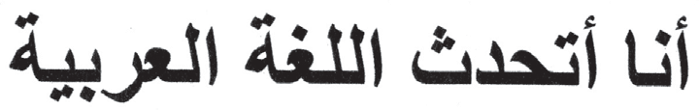
Armenian

B
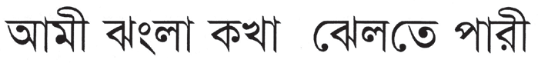
Bengali
Bosnian
Ja govorim bosanski
Bulgarian
Аз говоря български
Burmese

C
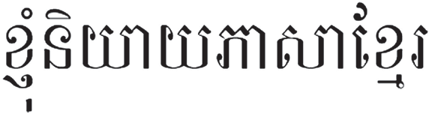
Cambodian

Cantonese
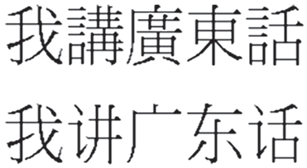
Catalan
Parlo català
Croatian

(Traditional) (Simpliﬁed)

Govorim hrvatski
Czech
Mluvím česky

D
Danish
Jeg taler dansk
Dari
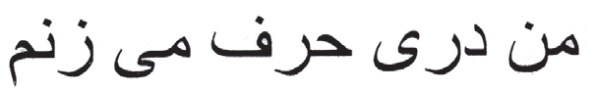
Dutch
Ik spreek het Nederlands

E
Estonian
Ma räägin eesti keelt

F
Finnish
Puhun suomea
French
Je parle français

G

German
Ich spreche Deutsch
Greek
Μιλώ τα ελληνικά
Gujarati
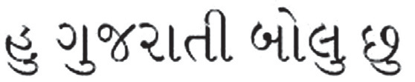

H

Haitian Creole
M pale kreyòl ayisyen
Hebrew
Hindi
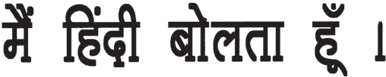
Hmong
Kuv has lug Moob
Hungarian
Beszélek magyarul

I

Icelandic
Èg tala íslensku
Ilocano
Agsaonak ti Ilokano
Indonesian
syay bisa berbahsa Indonesia
Italian
Parlo italiano

J
Japanese
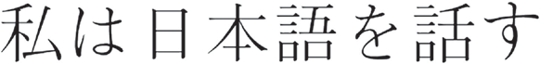

K

Kackchiquel
Quin chagüic ́ká chábal ́ ruin ́ rí tzújon cakchiquel
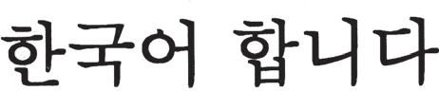
Korean
Kurdish
man Kurdii zaanim
Kurmanci
man Kurmaanjii zaanim

L

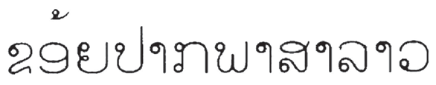
Laotian

Latvian
Es runâju latviski
Lithuanian
Að kal bu lietuviš kai

M

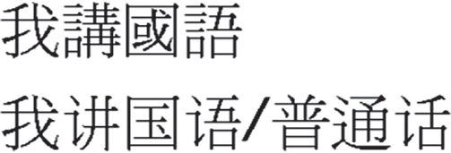Mandarin
(Traditional)

Mam
(Simpliﬁed)

Bán chiyola tuj kíyol mam
Mon
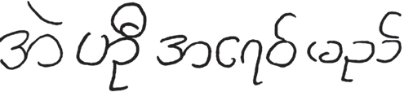

N

Norwegian
Jeg snakker norsk

P

Persian
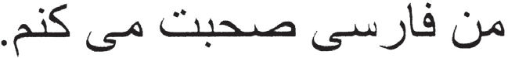
Polish
Mówię po polsku
Portuguese
Eu falo português do Brasil
(for Brazil)
Eu falo português de Portugal
(for Portugal)
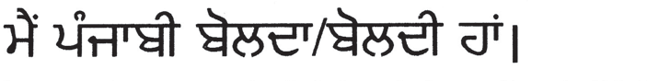
Punjabi

Q

Qanjobal
Ayin tí chí walq´ anjob´ al
Quiche
In kinch´aw k´uin ch´e quiche

R

Romanian
Vorbesc româneşte
Russian
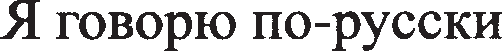

S

Serbian
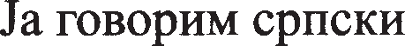
Sign Language (American)
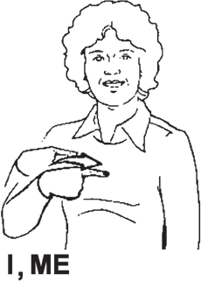
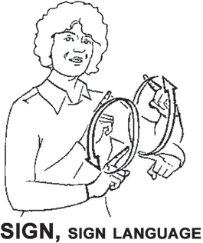

Slovak
Hovorím po slovensky
Slovenian
Govorim slovensko
Somali
Waxaan ku hadlaa af-Soomaali
Spanish
Yo hablo español
Swahili
Ninaongea Kiswahili
Swedish
Jag talar svenska

T

Tagalog
Marunong akong mag-Tagalog
Tamil
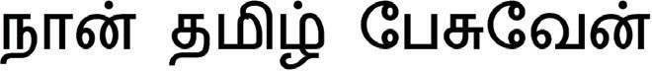

Thai
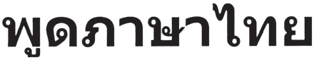
Turkish
Türkçe konuşurum

U
Ukrainian
Я розмовляю українською мовою
Urdu
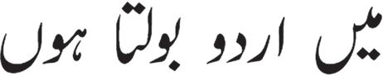

V
Vietnamese
Tôi nói tiêng Việt

W
Welsh
Dwi’n siarad

X
Xhosa
Ndithetha isiXhosa

Y
Yiddish
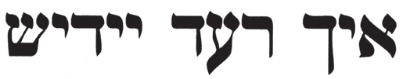
Yoruba
Mo nso Yooba

Z
Zulu
Ngiyasikhuluma isiZulu

Agrupación  Lingüística | Variante Lingüística | Frase en español | Frase en lengua
chichimeo jonaz | chichimeco jonaz | yo hablo chichimeca | ikáuj úza’ ér~í
mazateco | mazateco del norte | yo hablo mazateco Hablo la lengua de Santa María Chilchotla | Cha’ña enná  Cha’ña énn nda xo
maya | maya | Yo hablo maya | teen k-in t’aan maya
mixe | mixe bajo | Yo hablo mixe | Madyakpiëch ayuuk
 | mixe alto, de Tlahuitoltpec | Yo hablo mixe | Xaamkëjxpët ayuujk ëts nkajpyxypy
mixteco | mixteco del oeste de la costa | yo hablo mixteco | Yuu kain se’en savi ñu ñundua
Selected Indigenous Languages of Mexico
16

Agrupación  Lingüística | Variante Lingüística | Frase en español | Frase en lengua
náhuatl | náhuatl de la huasteca veracruzana  (se entiende junto con Ve  racruz y San Luis Potosí) | yo hablo náhuatl | Na nitlajtowa  náhuatl
tojolabal | tojolabal | yo hablo tojolabal | Ja´ke´ni wala  kúmaniyon tojol-abál
triqui | triqui de la baja | yo hablo triqui | ‘unj a’mii xna’  ánj nu’ a
tseltal |  | Yo hablo tseltal | Te jo’one ja k’op te  bats’il k’op tseltal
tsotsil |  | Yo hablo tsotsil | Vu’une jna’xi k’  opoj ta bats’i k’op
zapoteco | zapoteco de la planicie costera | yo hablo zapoteco | Naa riné’ diidxazá
chinanteco | chinanteco del sureste  medio | yo hablo  chinanteco | Jnea lo’n jujmií kiee  ’ dsa mo’ kuöo
Selected Indigenous Languages of Mexico
17

G - pg. 6 German Greek Gujarati
M - pg. 10
Mandarin Mam Mon

N - pg. 10
Norwegian

P - pg. 11
Persian Polish Portuguese Punjabi

Q - pg. 11
Qanjobal Quiche

R - pg. 12
Romanian Russian

S - pg. 12, 13
Serbian
Sign Language Slovak Slovenian Somali Spanish Swahili Swedish
A - pg. 3 Amharic Arabic Armenian

B - pg. 3 Bengali Bosnian Bulgarian Burmese

C - pg. 4 Cambodian Cantonese Catalan Croatian Czech

D - pg. 5 Danish Dari Dutch

E - pg. 5
Estonian

F - pg. 5 Finnish French

H - pg. 7 Haitian Creole Hebrew
Hindi Hmong Hungarian

I - pg. 8 Icelandic Ilocano Indonesian Italian

J - pg. 8
Japanese

K - pg. 9 Kackchiquel Korean Kurdish Kurmanci

L - pg. 9 Laotian Latvian Lithuanian
T - pg. 13, 14
Tagalog Tamil Thai Turkish

U - pg.14
Ukrainian Urdu

V - pg.14
Vietnamese

W - pg. 14
Welsh

X - pg. 15
Xhosa

Y - pg. 15
Yiddish Yoruba

Z - pg. 15
Zulu

See page 16,17 for selected indigenous languages
of Mexico.

Limited English Proficiency Resources
www. l e p . gov

“I Speak” is provided by the Department of Homeland Security Office for Civil Rights and Civil Liberties (CRCL). Special thanks to the Department of Justice Bureau of Justice Assistance and the Ohio Office of Criminal Justice Services, for inspiration and permission to use their “I Speak” guide as the initial source.

Office for Civil Rights and Civil Liberties
www.dhs.gov/crcl
Toll Free: 1-866-644-8360 Toll Free TTY: 1-866-644-8361
Email: crcl@dhs.gov
