Writing Social Media Posts
Include a brief quote from a personal story illustrating the mobile market’s impact to your neighbors or about the specific services being provided by volunteers at your agency. Include the date, time, location of the distribution event and a hashtag or link to more detailed information (i.e.: https://careandshare.org/findfood/)

Facebook example post:
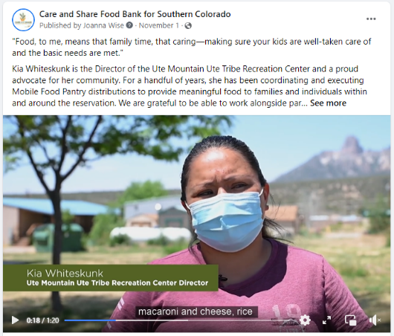
"Food, to me, means that family time, that caring—making sure your kids are well-taken care of and the basic needs are met." Kia Whiteskunk is the Director of the Ute Mountain Ute Tribe Recreation Center and a proud advocate for her community. For a handful of years, she has been coordinating and executing Mobile Food Pantry distributions to provide meaningful food to families and individuals within and around the reservation. We are grateful to be able to work alongside partners like Kia to serve Native American and Indigenous communities in Southern Colorado. #NativeAmericanHeritageMonth

Instagram example post:
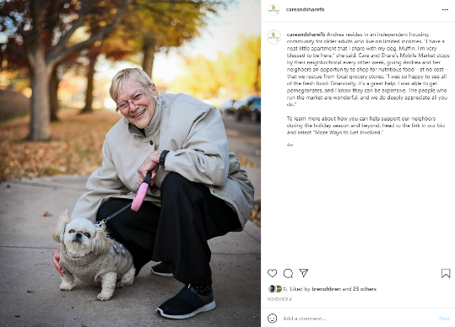

careandsharefb Andrea resides in an independent housing community for older adults who live on limited incomes. “I have a neat little apartment that I share with my dog, Muffin. I’m very blessed to be here,” she said. Care and Share’s Mobile Market stops by their neighborhood every other week, giving Andrea and her neighbors an opportunity to shop for nutritious food—at no cost—that we rescue from local grocery stores. “I was so happy to see all of the fresh food! Financially, it’s a great help. I was able to get pomegranates, and I know they can be expensive. The people who run the market are wonderful, and we do deeply appreciate all you do.”
To learn more about how you can help support our neighbors during the holiday season and beyond, head to the link in our bio and select “More Ways to Get Involved.”

Twitter example post:
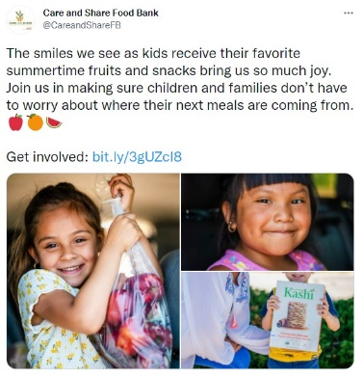
Care and Share Food Bank @CareandShareFB
The smiles we see as kids receive their favorite summertime fruits and snacks bring us so much joy!
Join us in making sure children and families don’t have to worry about where their next meals are coming from.
Get involved: http://bit.ly/3gUZc18

