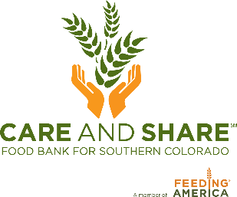

Mobile Market Toolkit Materials – Sample Email to Neighbors You Serve

[Enter Salutation to parents, school faculty, residents, neighbors],
We’re excited to share that we’ll be partnering with Care and Share Food Bank to bring their Mobile Market program to our location! Anyone in need of extra food assistance is welcome to attend upcoming distributions.
How does it work? [Enter how often i.e. Each week/Every other week], Care and Share’s Mobile Market will be at [enter location/details about where specifically] from [enter time]. We like to describe it as a grocery store on wheels. There will be a variety of food available—fruits, vegetables, bread, snacks, shelf-stable items. You can pick out and bag the food you want, and then take it home to share with your family.
All of the food is free of charge. No information is needed and there are no requirements. We will have a volunteer on hand asking some simple questions like:
- How many adults, children, and seniors are in your household
- What zip code you live in
- If you’ve attended the distribution before
These questions are only asked so Care and Share can keep track of how many people they’re serving within their service area.
Our first distribution [or next distribution] is on [enter date] from [enter times.]
If this is something that can help you and your family, we hope to see you there!

Thank you,
[Enter signature]

