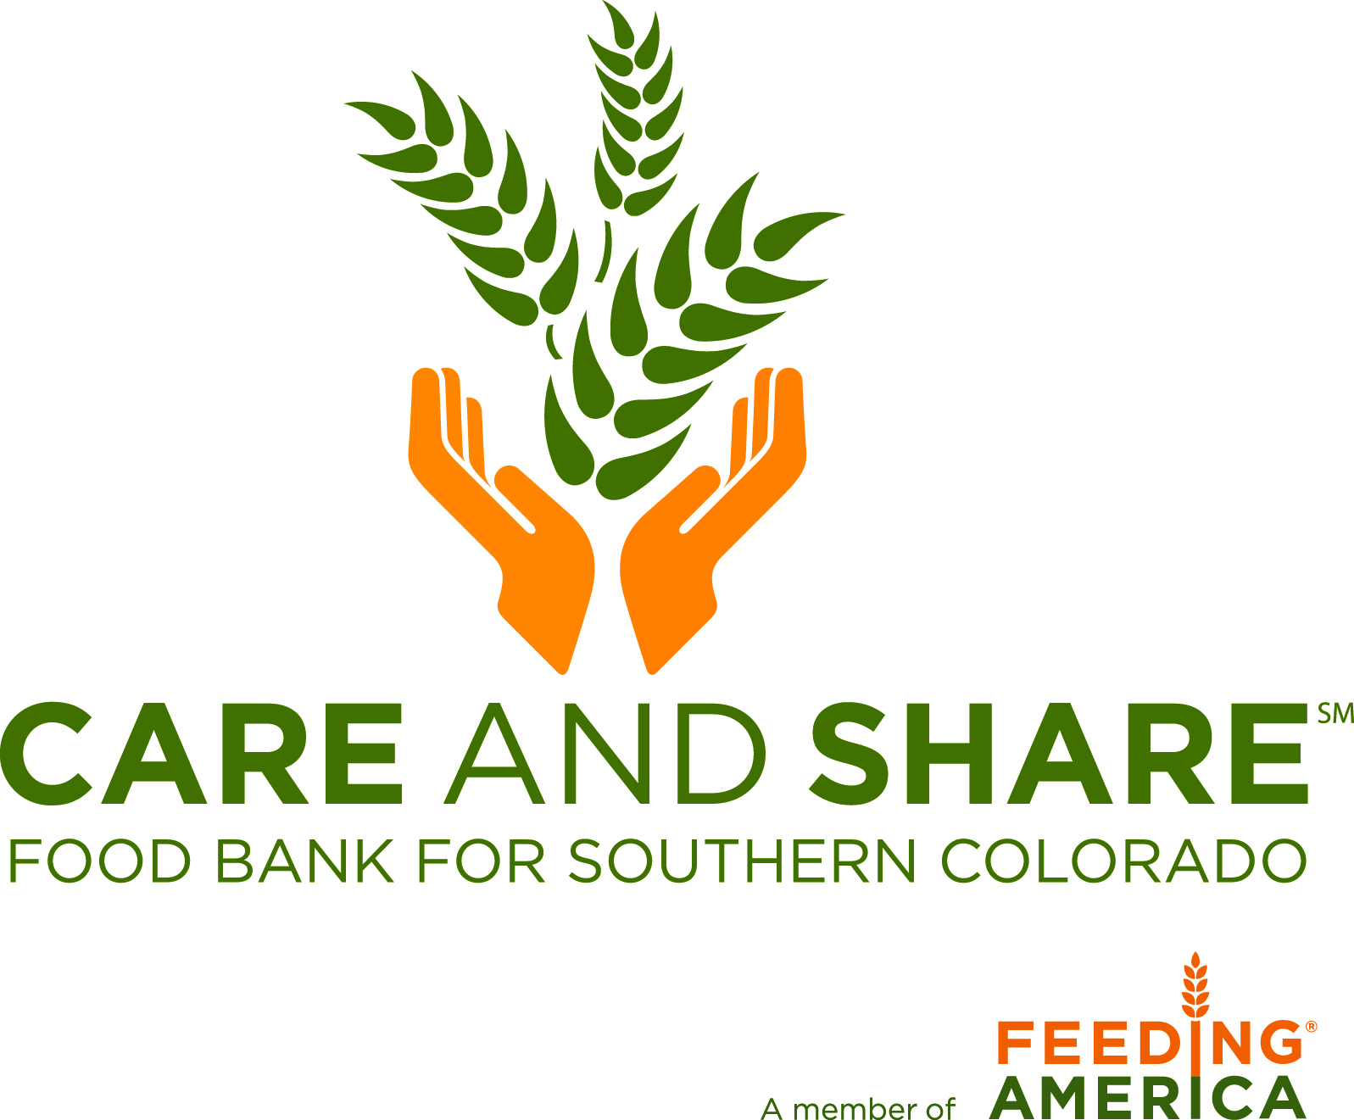
SERVSAFE
Safe Food Handler Certification

ServSafe is an independent company, not associated with Care and Share. Any technical issues or questions regarding the ServSafe website or food safety course should be directed to ServSafe at 1-800-765-2122.

As a Care and Share partner agency, at least one person who works directly with your program must hold a safe food handler’s certificate. ServSafe offers an online 2-hour food safety course for a 3-year safe food handler certification. To sign up and complete the course, visit https://www.servsafe.com/access/ss/Catalog/ProductList/22.

You will be directed to a webpage called ‘ServSafe Food Handler Program.’ You will need to select the first option ‘ServSafe Food Handler Online Course and Assessment BUNDLE’ for $15.00. After clicking the course link, you’ll click the ‘Add to Cart’ button at the bottom right of the screen.

The ‘Add to Cart’ button will take you to a login page. If you have a user ID and password already, you may enter it here. If not, you’ll need to create a ServSafe account by clicking the ‘Create New Profile’ button. Fill in the fields to create a new account.

Once you’ve registered, you will be directed to a page and should click the light blue ‘My Cart’ button under the green box in the middle of your screen. Click the blue ‘Checkout’ button to complete your course purchase. Your shipping information will be automatically filled in from your registration. Click the blue ‘Continue’ button, and enter your Billing Information, then click ‘Continue’ again. Before clicking the blue ‘Checkout’ button, be sure to enter FEEDAMER10 into the Coupon Code box then click ‘Apply Coupon’ to purchase the course for the discounted cost of $10.50. Finally, click the ‘Checkout’ button to complete your course purchase.

Be sure to remember your username and password to log in to ServSafe. You can start and stop the class as many times as needed. ServSafe will take you to where you last left off in the course each time you log in.

Once you complete the course, you will receive a certificate. Care and Share will need a copy of this certificate either faxed, mailed or emailed to us for your agency’s file.

